FOR REVIEW AND APPROVAL 8 OCTOBER 2026

IDS project tracker database ERD
Please review and approve this proposed relational database before implementation. It covers the current tracker and the Pehur High Level Canal Extension Project data template, including requests to extend component deadlines.

Decision requested
Approve the entity structure, the extension approval rules, and the open decisions in the approval section. Database creation, migrations, imports, and conversion of the website to dynamic content remain a separate step after your explicit approval.

Main design
Use one project record across cards, charts, lists, details, issues, meetings, comments, and logs. Preserve dated financial reports and deadline history instead of replacing earlier values. Store partner, district, sector, and user assignments as relationships rather than name lists.
Area | Proposed behaviour
Project classification | Pipeline or Ongoing; independent flagship flag. Health is On track or Off track, calculated from unresolved issues and overdue work. No On hold status.
Delivery | Configurable stages and components, with child subcomponents where needed. The current demo counts are not database limits.
Deadline changes | Request, review, approve or reject; preserve original and effective dates and every decision.
Financial reporting | Keep currencies, reporting periods, as-of dates, revisions, and sources explicit. Never add PKR and USD directly.
Accountability | Authenticated users, assigned-project access, per-user read markers, notifications, and append-only audit history.

Review basis
Source: Pehur High Level Canal Extension Project.docx, sections A to I, supplied by the user. Application review: routes, forms, templates, controllers, current schema, and read-only visual checks of nine main pages. The current interface uses ten static sample projects.

DATABASE DESIGN PROPOSAL

Website coverage
The proposed tables support both the visible presentation pages and the retained modules that will need authorization before dynamic use.
Website area | Database support
Landing and demo login | Static branding can remain in templates; real sign-in uses users and roles.
Dashboard and project list | Projects, stage classification, sector/district/partner links, calculated health, flagship flag. Charts and filters use the same query scope.
General information | Projects, contacts, organizations, project cost versions, and documents.
Pipeline journey | Project stages and ordered work items; a current pipeline item is explicitly selected.
Physical progress | Parent and child work items, progress updates, responsible users and organizations.
Financial information | Financing agreements, reporting years and quarters, approved report revisions, totals and period values.
Issue bell and project issues | Issues and issue updates; unresolved counts refer to distinct projects, not the number of issue records.
Project chat and dashboard comments | Comments with parent replies, read markers and recipient notifications; remove browser-only storage.
Meeting highlights and upcoming meetings | Meetings, linked projects, participants, action items and per-user versioned read markers.
Users and roles | Users, roles, permissions, project assignments and external contacts.
Reference lists | Organizations, districts, sectors and currencies with active flags.
Documents and logs | Document metadata and explicit links; immutable audit events.
Hidden reports and subactivities | Subactivities are child work items. Report exports are generated from scoped queries; saved report jobs are optional.

DATABASE DESIGN PROPOSAL

Pehur data mapping and reconciliation
The attachment is a populated collection template, not an approved database specification. Values below are retained as source claims until the responsible department confirms them.
Source item | Mapping and review action
Project identity | PHLCE-001; Irrigation Department; ADB; Water irrigation; Nowshera and Swabi. Store a single project with two district links.
Dates | Start 9 June 2017. Original closing 30 June 2023; revised closing 30 June 2027. Preserve both. Do not invent an extension approval date or approver.
Cost and financing | PC-I cost PKR 15,654 million. Net commitment USD 74.4 million; disbursed USD 68.2 million; balance USD 6.2 million as of 9 September 2026.
Conflicting annual records | Two rows are labelled FY 2026-27: USD 10m target / 5.46m achieved, and USD 6.9m / 0.72m. Keep separate source versions pending confirmation; do not combine them.
Quarter plan mismatch | Q1 1.2 + Q2 4 + Q3 0.34 + Q4 1.6 = USD 7.14m, exceeding the stated 6.9m annual target by 0.24m. These are planned disbursements, not actual releases.
Counterpart funding | PKR 290m allocation / 117m expenditure differs in scope from issue notes of 100m / 40m and 105.53m against 184m liabilities. Confirm scope and as-of date.
Stage and component detail | Ongoing execution with concurrent PC-I revision; four components are supplied, no child-level data. Do not force the project back to Pipeline or create fictional subcomponents.
Progress and issues | 85.8% is reported overall civil-works progress, not a measured value for each LOT. Six issues have missing severity, owners or raised dates; leave these null pending confirmation.
Contact anomaly | Zar Gul is named Project Director. Office/department contains a phone number; confirm the office separately. Blank approval forum/date must remain unknown.

DATABASE DESIGN PROPOSAL

ERD for project organization
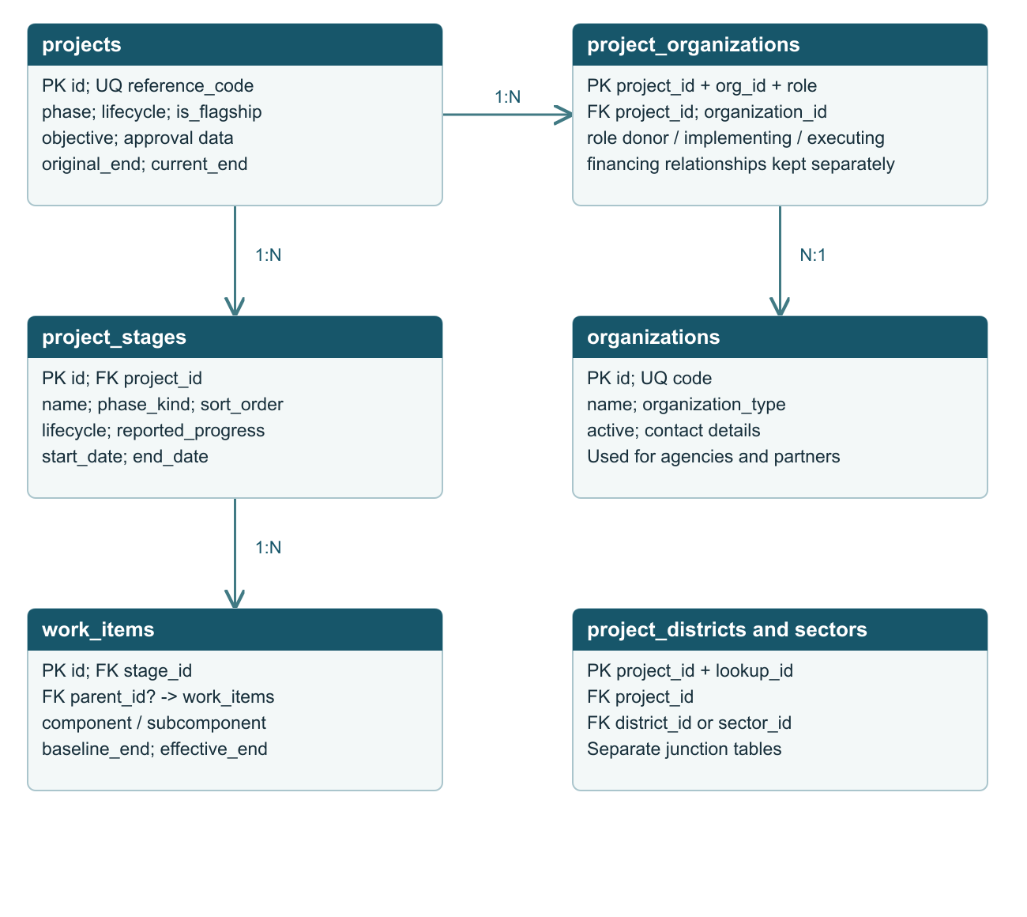
PK = primary key FK = foreign key 1:N = one to many ? = optional reference. N permits zero or more dependent records. N:1 arrows point toward the parent. Supporting relationships are specified in the field catalogue.
Each district and sector belongs to its own lookup table. Junctions support multiple values without duplicate project totals. Users, contacts and financial records connect through project_id.

DATABASE DESIGN PROPOSAL

ERD for access and responsibility
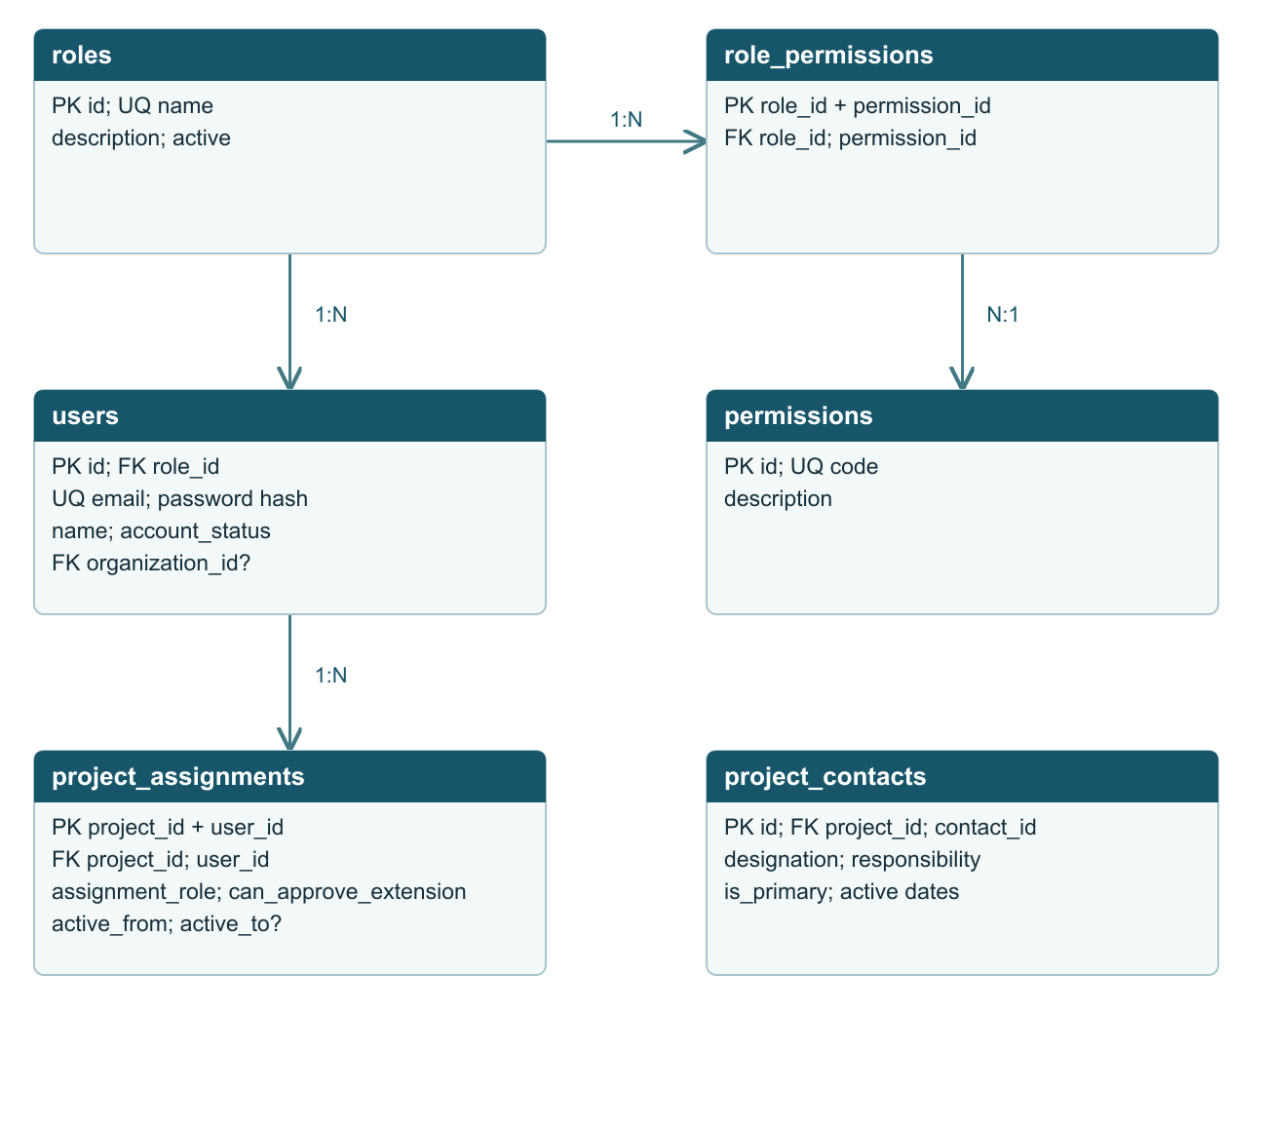
PK = primary key FK = foreign key 1:N = one to many ? = optional reference. N permits zero or more dependent records. N:1 arrows point toward the parent. Supporting relationships are specified in the field catalogue.
A project has many assignments and contact links. contacts may optionally link to a user, but an external focal person does not require a login. Permissions authorize an action; project assignments constrain which records the user can access.

DATABASE DESIGN PROPOSAL

ERD for progress and extensions
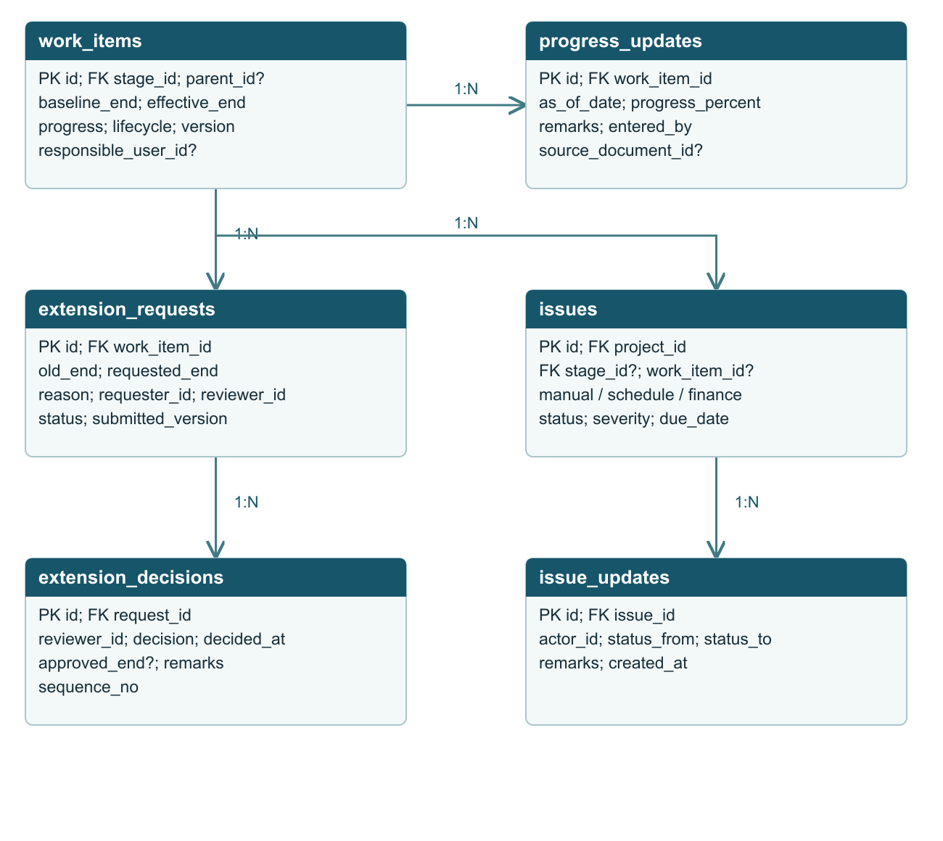
PK = primary key FK = foreign key 1:N = one to many ? = optional reference. N permits zero or more dependent records. N:1 arrows point toward the parent. Supporting relationships are specified in the field catalogue.
Issue work_item_id is optional for project-level issues. Both components and child subcomponents use work_items. A parent must be in the same project stage. Extension evidence attaches through document_links.

DATABASE DESIGN PROPOSAL

ERD for financial reporting
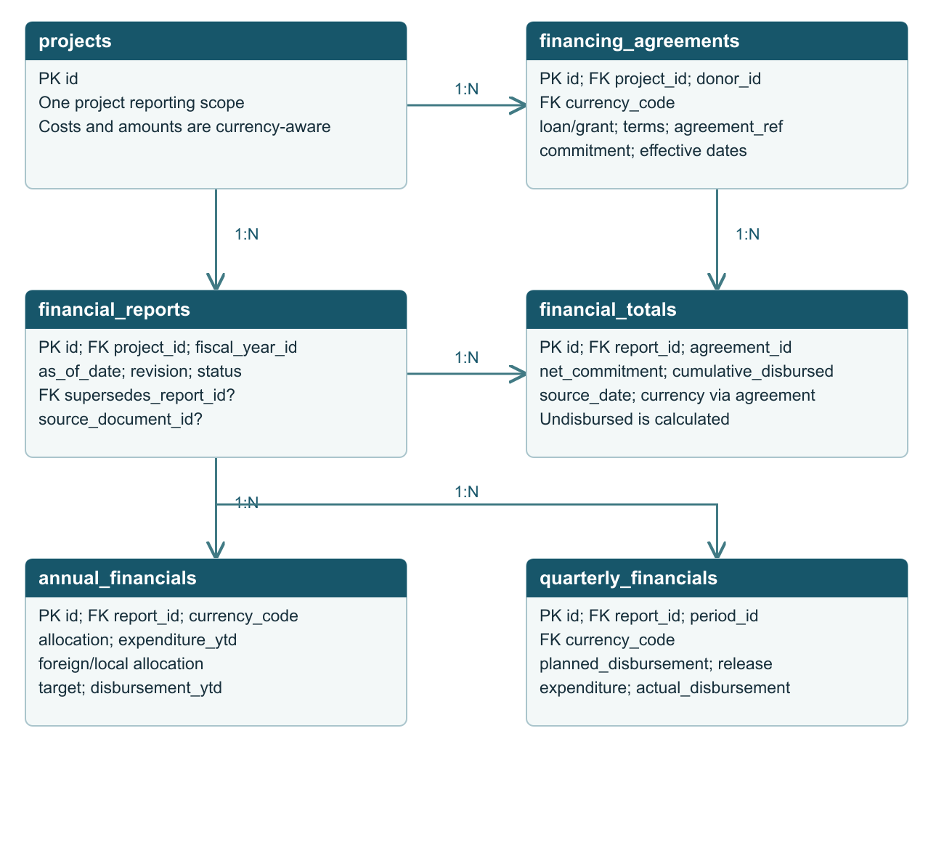
PK = primary key FK = foreign key 1:N = one to many ? = optional reference. N permits zero or more dependent records. N:1 arrows point toward the parent. Supporting relationships are specified in the field catalogue.
financial_years owns four reporting_periods. project_cost_versions records approved original and revised project costs separately. Only the selected approved report revision supplies charts. Totals and period values are never summed together.

DATABASE DESIGN PROPOSAL

ERD for collaboration and history
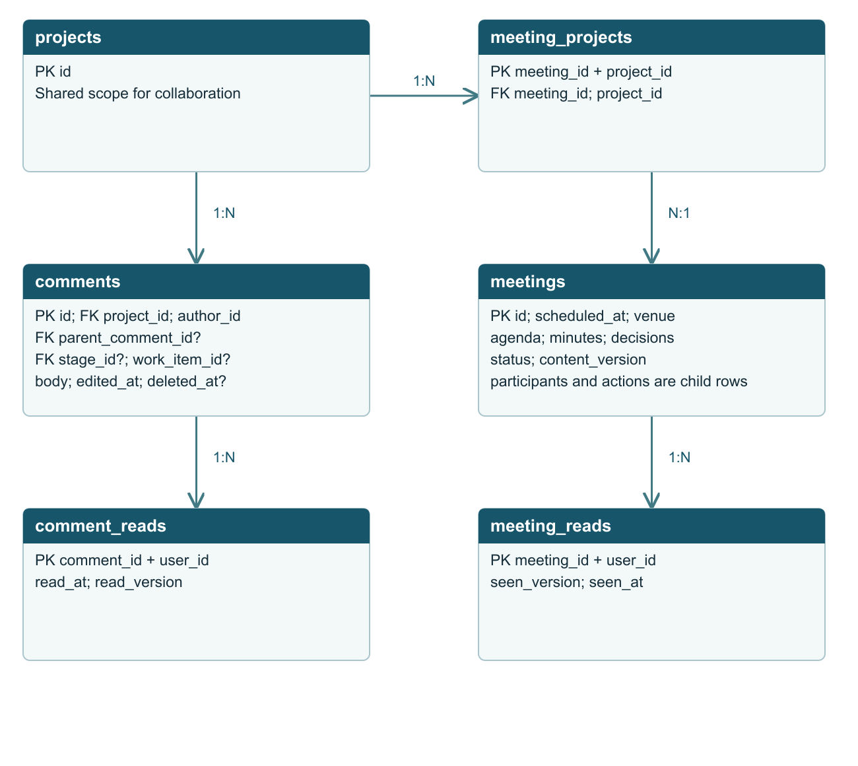
PK = primary key FK = foreign key 1:N = one to many ? = optional reference. N permits zero or more dependent records. N:1 arrows point toward the parent. Supporting relationships are specified in the field catalogue.
documents has many document_links to one target per link. notifications belongs to one recipient and references one event target. audit_logs stores actor, subject identity, action, timestamp and redacted before/after values; it survives subject deletion.

DATABASE DESIGN PROPOSAL

Fields for accounts and reference data
This is a logical schema for approval. Proposed physical defaults: bigint IDs, UTC timestamps displayed in Asia/Karachi, date-only deadlines, decimal amounts and explicit foreign keys. PK and FK fields below are required unless marked optional.
Table | Principal fields and constraints
users | id PK; role_id FK; organization_id FK optional; name; email unique; password hash; account_status; email_verified_at. Disable accounts rather than deleting their history.
roles | id PK; name unique; description; active. Proposed one role per user initially; project-specific authority lives in assignments.
permissions and role_permissions | permissions: id PK, code unique, description. role_permissions: role_id + permission_id composite PK and FKs. No names used as permission keys.
organizations | id PK; code unique; name; organization_type; active; contact information. Departments, executing agencies, implementing agencies and development partners are represented here.
contacts | id PK; organization_id FK optional; user_id FK optional; name; designation; email; phone; office. Preserve external contacts independently of user accounts.
districts and sectors | Each: id PK; code unique; name; active. Maintain district values as reference data; do not assume a fixed district count.
currencies | code PK, such as PKR or USD; name; decimal_places. Currency is required for every financial amount group.
project_assignments | project_id + user_id composite PK and FKs; assignment_role; can_approve_extension; active_from; active_to optional. Enforce project visibility here.
project_contacts | id PK; project_id FK; contact_id FK; designation; responsibility; is_primary; active_from; active_to optional. Historical focal-person assignments remain available.

Common columns
Mutable business tables include created_at, updated_at, created_by and updated_by. Actor fields reference users. Only auditable retirement is allowed for referenced lookups. Business tables use archived_at where appropriate; events and historical revisions remain immutable.

DATABASE DESIGN PROPOSAL

Fields for the project portfolio
Table | Principal fields and constraints
projects | id PK; reference_code unique; adp_code optional; name; objective; phase (Pipeline or Ongoing); lifecycle (Active, Completed, Cancelled); is_flagship; approval_forum optional; approval_date optional; start_date; original_end_date; current_end_date; source_rating optional.
project_organizations | project_id + organization_id + role composite PK; both IDs are FKs. Role is donor, implementing, executing or sponsoring. The same organization can have multiple roles.
project_districts | project_id + district_id composite PK and FKs. Counts use distinct project IDs. A project covering two districts appears under both district bars.
project_sectors | project_id + sector_id composite PK and FKs. Multi-sector projects follow the same distinct counting rule.
project_phase_history | id PK; project_id FK; from_phase; to_phase; changed_by FK; changed_at; reason. A stage revision does not automatically change the project phase.
project_stages | id PK; project_id FK; name; phase_kind; sort_order; lifecycle; planned_start; planned_end; actual_start/end optional; current_work_item_id optional; reported_progress optional; progress_as_of optional; remarks.
project_schedule_revisions | id PK; project_id FK; revision_no; previous_end; revised_end; approved_by/date optional for historical imports; source_document_id; reason. Preserve every project closing-date revision.
project_cost_versions | id PK; project_id FK; version_no; currency_code FK; total_cost; foreign_cost optional; local_cost optional; approved_on optional; effective_on; supersedes_id optional; source_document_id optional; remarks. Unique project_id + version_no.

Project health and flagship behaviour
Flagship is a boolean classification, independent of stage and health. On track and Off track are calculated labels, not manually editable project lifecycle values. Off track means at least one unresolved manual issue, current overdue work item or enabled financial-rule breach. Count the project once, even when it has several issues.

Pehur stage handling
Pehur remains Ongoing while a PC-I revision is pending. Store the revision as a parallel project stage or approval work item. Preserve the reported 85.8% stage-level civil-works progress with its as-of date; do not infer individual LOT percentages.

DATABASE DESIGN PROPOSAL

Fields for work and issues
Table | Principal fields and constraints
work_items | id PK; stage_id FK; parent_id FK optional; type component/subcomponent; name; sequence_no; description; planned_start, baseline_end and effective_end optional until confirmed; actual_start/end optional; lifecycle; weight optional; responsible_user_id / organization_id optional; version.
progress_updates | id PK; work_item_id FK; as_of_date; progress_percent; status; remarks; entered_by FK; source_document_id optional. Progress is 0 to 100. Latest accepted update drives the card; history is retained.
extension_requests | id PK; work_item_id FK; requester_id FK; reviewer_id FK; old_end_date; requested_end_date; reason; impact; status (Draft, Pending, Returned, Approved, Rejected, Withdrawn); submitted_at; submitted_item_version; supersedes_request_id optional; withdrawn_at optional.
extension_decisions | id PK; request_id FK; reviewer_id FK; sequence_no; decision; approved_end_date optional; remarks; decided_at. Unique request_id + sequence_no. Terminal decisions are immutable.
issues | id PK; project_id FK; stage_id FK optional; work_item_id FK optional; rule_id FK optional; origin manual/schedule/finance; title; description; severity optional; owner_user_id or organization_id optional; raised_at optional for imports; due_date optional; status; resolved_at/by optional; resolution.
issue_updates | id PK; issue_id FK; actor_id FK; status_from; status_to; note; created_at. Reopening a resolved issue creates a new transition.
issue_rules | id PK; code unique; rule_type; enabled; version; parameters; approved_by optional. Schedule rule can be enabled after approval. Financial thresholds stay disabled until supplied and approved.

Hierarchy and completion
Pipeline components have no required children. Ongoing components may have subcomponents. Enforce a maximum of two levels initially, no circular parents, and a shared stage for parent and child. Do not hard-code four, five or six components.
Proposed progress policy: use approved weights for child-to-parent rollups; where weights are missing, show reported progress and its source rather than silently averaging. Stage and project progress must identify whether they are reported or calculated.

DATABASE DESIGN PROPOSAL

Fields for financial reporting
Table | Principal fields and constraints
financing_agreements | id PK; project_id FK; donor_id FK to organizations; agreement_ref; financing_type; currency_code FK; original_commitment; signing_date; effective_date; maturity_years optional; grace_years optional; interest_basis; remarks.
financial_years | id PK; label unique; start_date; end_date. Proposed Pakistan fiscal year runs 1 July to 30 June; confirm before implementation.
reporting_periods | id PK; financial_year_id FK; quarter_no 1 to 4; start_date; end_date. Unique financial_year_id + quarter_no.
financial_reports | id PK; project_id FK; financial_year_id FK; as_of_date; revision_no; status draft/approved/superseded; supersedes_report_id optional; source_document_id optional; submitted_by; approved_by optional.
financial_totals | id PK; report_id FK; agreement_id FK; net_commitment; cumulative_disbursed; source_as_of. Currency comes from agreement. Unique report_id + agreement_id. Undisbursed is net commitment minus cumulative disbursed.
annual_financials | id PK; report_id FK; currency_code FK; total_allocation; foreign_allocation optional; local_allocation optional; expenditure_ytd; cumulative_expenditure; disbursement_target; disbursement_ytd. Unique report_id + currency_code.
quarterly_financials | id PK; report_id FK; period_id FK; currency_code FK; planned_disbursement; actual_disbursement; release_amount; expenditure_amount; remarks. Unique report_id + period_id + currency_code.

Money and reporting rules
Use DECIMAL(20,2) amounts in base currency units, not floating point. Financial values may be null when not reported. Record the source unit during import; PKR 15,654 million becomes PKR 15,654,000,000. Format millions only in the view. Unknown values are null, not zero.
A quarterly actual is a period amount; a cumulative total is an as-of snapshot. Never sum repeated cumulative totals across quarters or report revisions. Achievement and utilization are calculated only when the denominator is positive; otherwise display Not available.

DATABASE DESIGN PROPOSAL

Fields for collaboration and evidence
Table | Principal fields and constraints
meetings and meeting_projects | meetings: id PK, title, scheduled_at, timezone, venue, online_link, agenda, minutes, decisions, status, content_version. meeting_projects: meeting_id + project_id composite PK/FKs.
meeting_participants | id PK; meeting_id FK; contact_id FK; role; attendance. Internal participants link through contacts.user_id. Unique meeting_id + contact_id.
meeting_actions | id PK; meeting_id FK; project_id FK; work_item_id / issue_id optional; description; assigned_user_id or organization_id; due_date; status; completed_at. Project must be linked to that meeting.
meeting_reads | meeting_id + user_id composite PK/FKs; seen_version; seen_at. Edited meeting content increments content_version and can reappear as unread.
comments and comment_reads | comments: id PK, project_id, author_id, parent_comment_id optional, stage_id/work_item_id optional, body, version, edited_at, deleted_at. comment_reads: comment_id + user_id PK/FKs, read_version, read_at.
documents | id PK; title; storage_disk; storage_path; original_filename; MIME type; size; checksum; uploaded_by FK; version; supersedes_document_id optional; uploaded_at. Files stored privately outside the database.
document_links | id PK; document_id FK; exactly one of project_id, work_item_id, issue_id, meeting_id, extension_request_id. All targets have real FKs. Unique document + target relationship.
notifications | id PK; recipient_user_id FK; project_id optional; event_type; one event target comment_id / issue_id / meeting_id / extension_request_id; read_at optional; created_at. Unique recipient + event identity.
audit_logs | id PK; actor_user_id optional; actor_name snapshot; subject_type; subject_id; project_id optional; action; before_values; after_values; request_id; occurred_at. Read-only history with secret redaction.
Replies inherit the parent project and context; cross-project replies are forbidden. Read markers describe viewing; notifications describe delivery. Audit subject identity is intentionally retained even if the original record is archived or removed.

DATABASE DESIGN PROPOSAL

Component extension workflow
Proposed approval policy: one assigned approving officer per request, with no self-approval. The reviewer must have the extension approval permission and an active assignment to the project. This policy is a recommendation for your approval.
Step | Required behaviour
Draft | Requester selects the component, proposes a later date, explains the reason and impact, and attaches evidence. Draft does not change the deadline.
Submit | Capture the current effective deadline and work-item version. Require a valid assigned reviewer. Allow only one pending request for the item. Notify the reviewer.
Review | Reviewer sees the original date, current date, all prior extensions, progress, open issues and supporting documents. Return for correction, reject, or approve with a reason.
Approve | In one database transaction: lock request and work item, verify status and version, insert decision, update effective_end and version, write audit event, queue notifications after commit.
Reject or withdraw | Save the reason and decision history. Leave effective_end unchanged. Permit a new request that references the earlier request.
Resubmit | Create an immutable new submission version after a return for correction. Preserve the previous submitted values; do not overwrite evidence already reviewed.
After approval | Recalculate schedule health against the approved effective date. Retain the earlier overdue period. Do not automatically resolve independent manual issues or financial breaches.

Deadline safeguards
The original baseline end date never changes. A requested or approved extension must be later than the captured current date. A stale request must be reviewed again if another approval changed the deadline. Completed or cancelled work cannot receive an extension unless formally reopened.
If the proposed date exceeds the parent component or project end date, block final approval until the corresponding parent/project schedule change is approved. A component extension must never silently extend the project. Pehur project-level historical revisions can be imported with source evidence and unknown approval metadata clearly marked.

DATABASE DESIGN PROPOSAL

Integrity and implementation rules

Prevent inconsistent project scope
Enforce same-project relationships for stages, work items, issues, meeting actions, comments and evidence. Use composite unique keys and FKs where supported, backed by service validation. Parent/child relationships must be acyclic. Use database constraints for unique codes, nonnegative amounts and valid progress ranges.

Keep a single calculation path
Dashboard totals, partner and district charts, project lists, issue notifications and general-information status must use the same authorized project query. Calculate distinct project counts. A report revision or approved extension must invalidate affected summary caches.

Retain history
Original deadlines, approved financial reports, extension decisions, progress updates and audit entries are append-only. Archive referenced projects and users. Do not cascade-delete history with a project or user. Correct approved data with a new revision and a reason.

Indexes and concurrency
Index projects(reference_code), issues(project_id,status), work_items(stage_id,parent_id,effective_end), extension_requests(work_item_id,status), progress_updates(work_item_id,as_of_date), comments(project_id,created_at), meetings(scheduled_at,status), notifications(recipient_user_id,read_at), and audit_logs(project_id,occurred_at). Add junction uniqueness and reporting composite keys described earlier.
Use transactions for project creation with relationships, issue transitions, report approval and extension decisions. Lock the request and work item when approving an extension. Enforce duplicate-request prevention transactionally, not only by hiding the submit button.

Access and privacy
Real sign-in replaces dummy access before production. Check both permission and project membership on every read and mutation, including downloads, chat and logs. Store passwords as hashes; redact credentials from logs. Uploaded files require size/type validation, private storage and authorized downloads.

Issue evaluation
Proposed schedule rule: effective_end is before today in Asia/Karachi and work is neither complete nor cancelled. Do not create duplicate open schedule issues for the same work item and rule. Missing dates produce an incomplete-data flag, not an invented deadline. Financial rules remain disabled until the owner provides formulas and thresholds.

DATABASE DESIGN PROPOSAL

Approval decisions and implementation sequence
Please approve this document or return changes before any new database tables, migrations or dynamic data conversion are implemented.
Decision | Proposed default for approval
Extension reviewer | Assigned approving officer; requester cannot self-approve. Confirm whether a Project Director and IDS administrator must approve in sequence instead.
Project deadline revisions | Keep original and current project dates with source evidence. Confirm whether future project-level requests need the same approval workflow as components.
Progress calculation | Reported progress with an as-of date; weighted rollups only after weights are approved.
Health and financial rules | On track / Off track from unresolved issues and overdue work. Financial indicators remain disabled until supplied.
Fiscal calendar and currency | July to June, four quarters. PKR and USD stored separately. Any consolidated currency view requires an approved exchange-rate source and conversion date.
Pehur source conflicts | Confirm the duplicate FY label, annual/quarter plan mismatch, counterpart figures, missing component dates and contact office.
Access and retention | Confirm who can view all projects and audit logs, document retention periods, and archive permissions.

After approval
1. Finalize the physical schema and database engine, take a backup, and create migrations in a separate development database. Preserve the existing tracker_records store until its records are mapped and checked.
2. Import confirmed master data and project information using stable IDs and explicit source mappings. Keep the ten demo projects separate from production records. Do not import placeholder component counts, random progress or browser-local demo comments as real history.
3. Replace static page sources in stages: project portfolio, components and issues, finances, meetings and chat, then notifications and audit logs. Add authorization and validation before enabling writes.
4. Verify counts, financial units, multi-district links, resolved issue history, unread markers and extension concurrency in tests and a user review. Switch the interface only after acceptance.
Approval record: Approved by ____________________ Date __________
Requested changes ______________________________________________

